Alison Trump

Business Intelligence solution

Prince Bhatia

2018

Table of Contents

Table of Contents

1. **Executive Summary 3**
2. **Business problem 4**
3. **Requirements Specification 4**
4. **Business Application 5**
5. **Artificial Neural Networks 6**
6. **Decision Trees 7**
7. **Linear Regression 8**
8. **Implementation 10**
9. **Conclusion 11**
10. **Executive Summary**

Alison Trump’s Investment management company manages investments that manages a substantial amount of assets for organisations and clients. The problem they face are timing for investments. They face the problem of when to buy and sell securities for its clients at the best optimal time. Their main objective or end goal is to provide their clients the maximum return on their assets while reducing their risk.

The main problem is broken down into sub problem which together address the main problem:

1. Identify the most suitable and most substantial securities for clients
2. To examine data more frequently to have the latest data for precision and reliability
3. To gather more significant, accurate and reliable data for basing decisions when to buy and sell securities

Solving these sub problems will ensure the main problem will be addressed. Alongside using appropriate business intelligence techniques. Implementing the BI system will take some time, as it is a complex system which will need to be tried and tested on numerous occasions to get right and to ensure al stakeholders are happy with the system. AT has one of the largest fund management firms in Australia and New Zealand. With the new BI solution implemented it will propel them to grow to become the largest firm in Australasia.

1. **Business problem**

The main problem for Alison Trump Investment Management company(AT) is timing. The company currently tries to determine if the market provides any signals on how it could behave in the intermediate terms. The data generated can’t be processed for analysis which makes the predictions not accurate and reflecting the best options.

1. **Requirements Specification**

The motivation for a new Business Intelligent solution came because of the current system not performing to the needs of the company. AT requires something that performs to maximizing the return on assets while have low risk. Currently the business is using intermediate terms to predict the market which is not trustworthy data nor efficient. The solution is to use Artificial Neutral Network(ANN). ANN would keep a track of the day to day markets and update the data to account for fluctuations. This BI is aimed to cater for any clients sought out after from AT.

The main goal for AT is to maximize the return on assets it invests in for its clients, while minimizing the risk exposure. To reach this goal, the main goal can be split into smaller goals, which together reflect the main goal. This ensures it is more successful.

1. **Identify the most suitable and most substantial securities for clients**

The stakeholder affected by this are the AT managers know as portfolio managers. Decisions Trees will be used by clients to choose which decision they will choose regarding which investment to go for when buying/selling.

The stakeholder AT managers is a person who has been given control and responsibility for investing people’s money into buying and selling securities or is someone who manages financial assets for other people.

The staff at AT, primarily the portfolio managers would be responsible for buying and selling stocks on behalf of clients. The new business intelligence solution(ANN) would be used predominantly by the AT manger, it would help aid in making decisions for buying and selling securities. This in return helps minimize risk significantly on the client side and increase the return on the investment in the long run.

1. **To examine data more frequently to have the latest data for precision and reliability**

The stakeholder for this is the computer scientists. Their role is to present the large data collected into a readable format for the clients to understand. This makes it easier for the clients to make sound business decisions wether to buy and sell securities.

The role of the computer scientist is to filter and accommodate the required data to the client. The business intelligence solution will generate a lot of data which will need to be processed by the computer scientist. Then the computer scientist decides which data should be forwarded on to the client.

1. **To gather more significant, accurate and reliable data for basing decisions when to buy and sell securities**

The stakeholder affected by this is the financial analysts. To better predict the share market on when to sell and buy securities linear regression and ANN(Artificial neural networks) will be used.

The stakeholder is financial analysts, their role is to perform financial forecasting and monitoring of the stock market. They rely heavily on tools to track metrics and predict forecasts.

The staff at AT would use ANN to generate an output of which stock to buy and sell for the client. But the unique factor would be the financial analyst getting involved to guide the client on whether to go through with it or not. The financial analyst would have done his own research which can help guide clients immensely. To help aid the financial analyst, linear regression is used to predict market share by using regression. This in return would give the financial analyst an insight towards which stocks are more beneficial in terms of high, low and average prices.

Clients- Stakeholder

The client stakeholder is anyone who wants to use AT services or get advice from the company. This stakeholder is the one who requires information provided by AT to make decisions on whether to buy or sell securities. Clients require specific information before basing their decisions on investments. AT provides these details to the client which tells them the stock in buyable or sellable. The new BI solution would be beneficial for the clients because, they would only need to decide wether to buy or sell the stock. The solution provides a low risk high return on their investment.

1. **Business Application**

Main problem broken into smaller problems:

-Identify the most suitable and most substantial securities for clients

-To examine data more frequently to have the latest data for precision and reliability

-To gather more significant, accurate and reliable data for basing decisions when to buy and sell securities

The new BI solution will include these solutions:

1. Machine Learning Algorithm
   1. Linear Regression
2. Artificial neural networks(ANN)
3. Machine Learning Algorithm
   1. Decisions trees
4. **Artificial Neural Networks**

Artificial neural network is the perfect fit for the 3rd subclass problem for AT. The main factors affecting the financial markets are inflation, deflation and interest rates. The aforementioned factors are macro economic factors:

1. Inflation

2. Deflation

3. Interest rates

The main objective to use ANN is to provide accurate and precise security stock predications so clients have a higher return while minimizing their risk. ANN is presented with huge data which makes it easier to detect patterns and trends.

1. Inflation

Inflation is the rise in the price of goods overtime. When there is inflation business tend to buy less and reduce their overall expenditure because of the high prices. Therefore, interest rates go up because the demand also increases. This makes it harder for businesses to expand their processed and growth of the company. This is due to the high interest rates for borrowing money, but also because of inflation, consumers have less disposable income to spend.

1. Deflation

Deflation is the decrease in the general price of goods. When there is deflation this means businesses are forced to lower their prices, therefore lowering the price of their stock. Interest rates drop as well allowing businesses access to cheap money to increase business activity’s and expand which raises the stock price, attracting people to buy more.

1. Interest Rates

Interest rates have a key function in inflation and deflation. If a bank is offering a company low interest rates, this allows the company to expand and have access to cheap money, therefore increasing business activity and output. This will attract investors to invest in the company because they have access to cheap money and drive the share price higher offering greater returns. If the interest rate is high, then the company will reduce its spending and therefore have a slower growth rate. This makes it less attractive for investors therefore dropping the share price overall.

ANN has two methods of learning, they comprise of supervised learning and unsupervised learning. Supervised leaning is the process of teaching the system i.e. training the system as we know the right answers. The dataset is given to ANN and it learns the patterns and tries to predict stock. Therefore, supervised can be given new data to work from and come up with these patterns. Un supervised learning is when the network is given a sample data to base patterns and clusters off to form similarities. Supervised leaning can be used to base stock predications from and unsupervised can be used to feed new data from the stock market to keep up to date with the market.

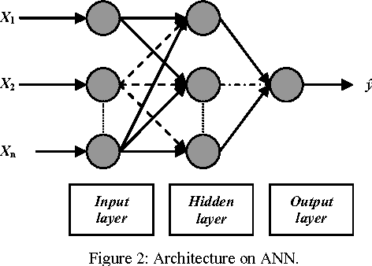

Figure 1

For this solution, we will be using the supervised approach. The input layer will be fed through with stock share data and new and updated stock data. The hidden layer are the economic factors. These are the factors such as inflation, deflation and interest rates. New data will update and make the current algorithm more accurate, therefore making the data output more reliable and predicable for stocks.

Inflation/Deflation

Stock Data

Buy or Sell Stock

Data Updated

*Figure 2*

Interest Rates

Figure 2 displays the data being updated into the BI system. It shows how data would be updated by using the macro economic factors. Inflation, Deflation and interest rates will be updated on a daily basis along with other factors to determine a result. Ann gives a predication of each stock output on whether it is valuable.

1. **Decision Trees**

This solution would be best for the 1st subclass problem. As it currently stands AT cannot identify the most profitable securities for its clients in the intermediate term. This problem addresses it as the Portfolio mangers and the clients will choose which investments to invest in and buying and selling securities. The BI solution will provide them with a compressive report on which are the most viable to invest in. The portfolio mangers can use decision trees which helps them break down the shares into smaller chunks that are manageable for the clients. This will reduce time and make it more efficient in the decision making process for portfolio managers.

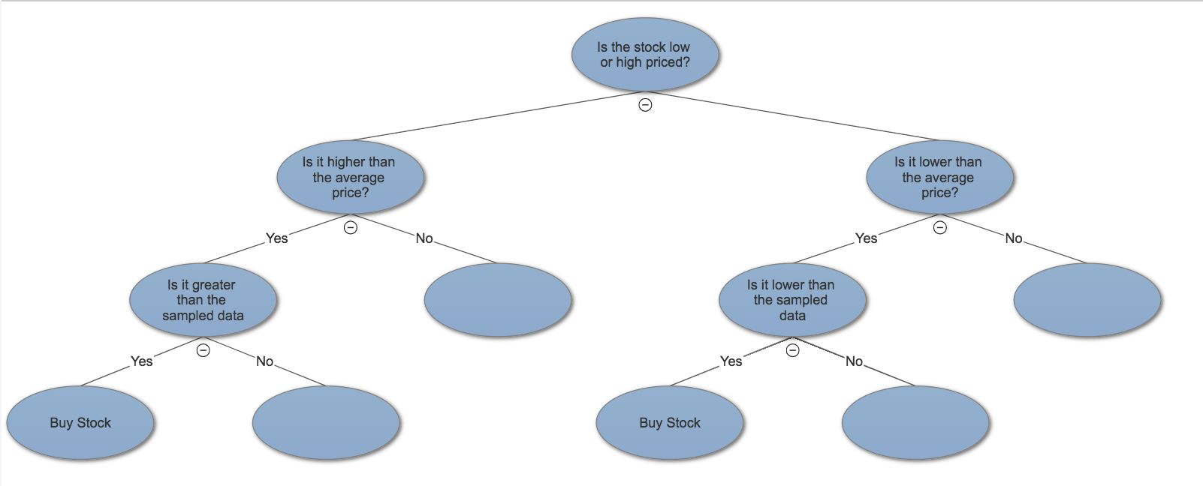

Figure 3

This is the decision process portfolio mangers would take for clients. This is the method taken to generate high return low risk. The first step is to determine if the stock is at an average high or low price. Then move onto whether is is lower or greater than the sampled data to buy or sell the stock for maximum return, lowest risk.

1. **Linear Regression**

Linear Regression would be used on a daily basis to monitor the stock market on prices. This would be used by computer scientists to predict whether a stock is high or low on price. This will be able to determine why a particular stock was high on a particular day to understand why this occurs and predict future stocks of such events. Overall this would help predict the price of stocks in the long run by using ANN. This graph shows the linear progression of the price of a stock. Overall this stock price has increased.

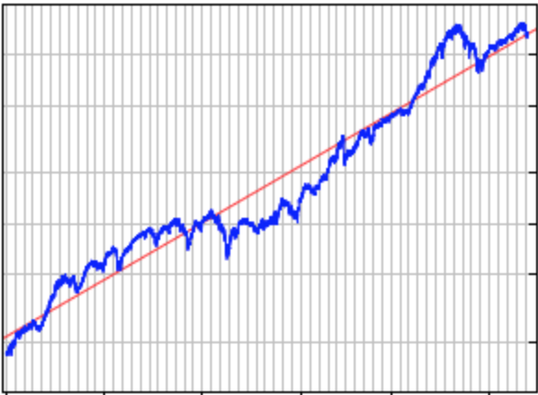

Figure 4

1. **Implementation**

The implementation of the new BI system should be done in such a manner that doesn’t disturb the current operations of AT or the current data. The factors to take into consideration are time and cost. The time to roll out the new system should not take to long, also the cost to do so should not be over budgeted to integrate the new system. Since the BI system is complex and requires a lot of tedious programming to get a successful outcome it should be implemented separately.

Implementation steps:

1. Make sure all the stakeholders are informed of the new implementation of the system
2. AT should identify some Critical success factors(CSF) to be able to measure the progress and see if the new system is a burden or efficient.
3. Once the system has been implemented ask for feedback from stakeholders
4. Perform feedback sessions with stakeholders to get the most feedback as possible
5. Analyze the feedback and respond accordingly
6. Develop a plan to improve the system based on the feedback collected
7. Implement the plan
8. Monitor the CSF again to track the progression
9. Generate a report for the CEO of AT to analyze
10. Make sure the system is performing at its peak and continue with maintenance where needed
11. Service and support
12. **Conclusion**

The current system AT has does not do a good job of identifying when the best time is to sell or buy security stocks. The new system implemented will provide a huge advantage to the company because of the predictability and factors which are taken into account when making the predications for stocks. The new solution will affect each stake holder in a positive way and making their work and data more efficient and useable. The use of BI will improve performance, analytical analysis and increase overall profits bringing in more cliental. One drawback of the system is that it does not account for the changes around the worlds which could affect the stock market. An example could be an election or a war happening. These things will greatly affect the prices of shares which are impossible to predict on how the stock market will react. In terms of the BI solution is could provide ambiguous data which can be unreliable.

Bibliography:

Abdullah, N.E., Hashim, H., Osman, F.N., & Adam, F.M. (2010). Comparison between various supervised ANN algorithm using RGB indices for plaque lesion classification. 2010 International Conference on Electronic Devices, Systems and Applications, 236-241.

Lee,C. (2008). Regression Lines. Retrieved from <http://stockblock.info/2008/04/regression-lines.html>